Lab: Connecting a UI
Goal: show how a basic client application can consume our API

Creating a console application
To demo consuming our API from a client application, we’ll create a basic console application.
Steps:
- In the Solution Explorer of our PieShopApi, add a new project to to the solution using the C# “Console App” template
(Right click the solution Add New Project)
- Name the project “PieShopConsoleClient”
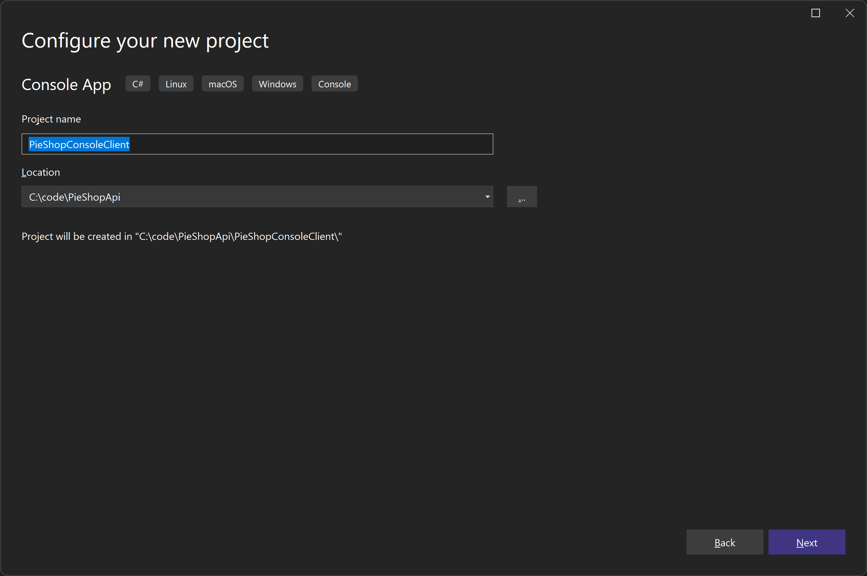
- Make sure .NET 8 is selected as the Framework and click create
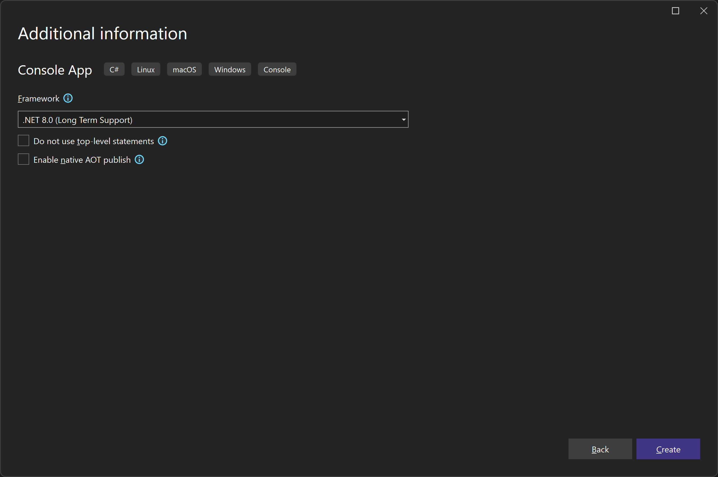
- A Program.cs file should have been created containing a “Hello World” message

Getting all Pies
In this part, we’ll add the code to call our API and GET all the Pies.
To do this, we use an instance of HttpClient.
Note that in real-world scenarios, it’s a bad practice to directly use instances of HttpClient, as calling the API multiple times from the same app can cause socket exhaustion.
Instead you should use IHttpClientFactory, which solve this issue gracefully.
To keep the demo simple, we’ll use HttpClient directly.
Steps:
- In the Program.cs file, add the code to GET all Pies from our API
Notice we call the GetAsync(“pies”) method and deserialize the result
using PieShopConsoleClient;
using System.Text;
using System.Text.Json;

Console.WriteLine("Press any key to get all pies");
Console.ReadKey();

using var client = new HttpClient();
client.BaseAddress = new Uri("https://localhost:7043");

var response = await client.GetAsync("pies");
response.EnsureSuccessStatusCode();

var pies = await response.Content.ReadAsStringAsync();

var piesList = JsonSerializer.Deserialize<List<Pie>>(pies, new JsonSerializerOptions { PropertyNameCaseInsensitive = true });

foreach (var pie in piesList)
{
Console.WriteLine($"{pie.Name} - {pie.Description}");
}

Console.WriteLine();
Console.ReadKey();
- Add a new class to the console project called “Pie.cs” and copy the structure of our Pie class from the API project
public class Pie
{
public int Id { get; set; }
public string Name { get; set; }
public string Description { get; set; }
}
- Launch the Web API application (F5)
- Right click the console application and select Debug Start new Instance
- Verify that the pies are listed in our console application
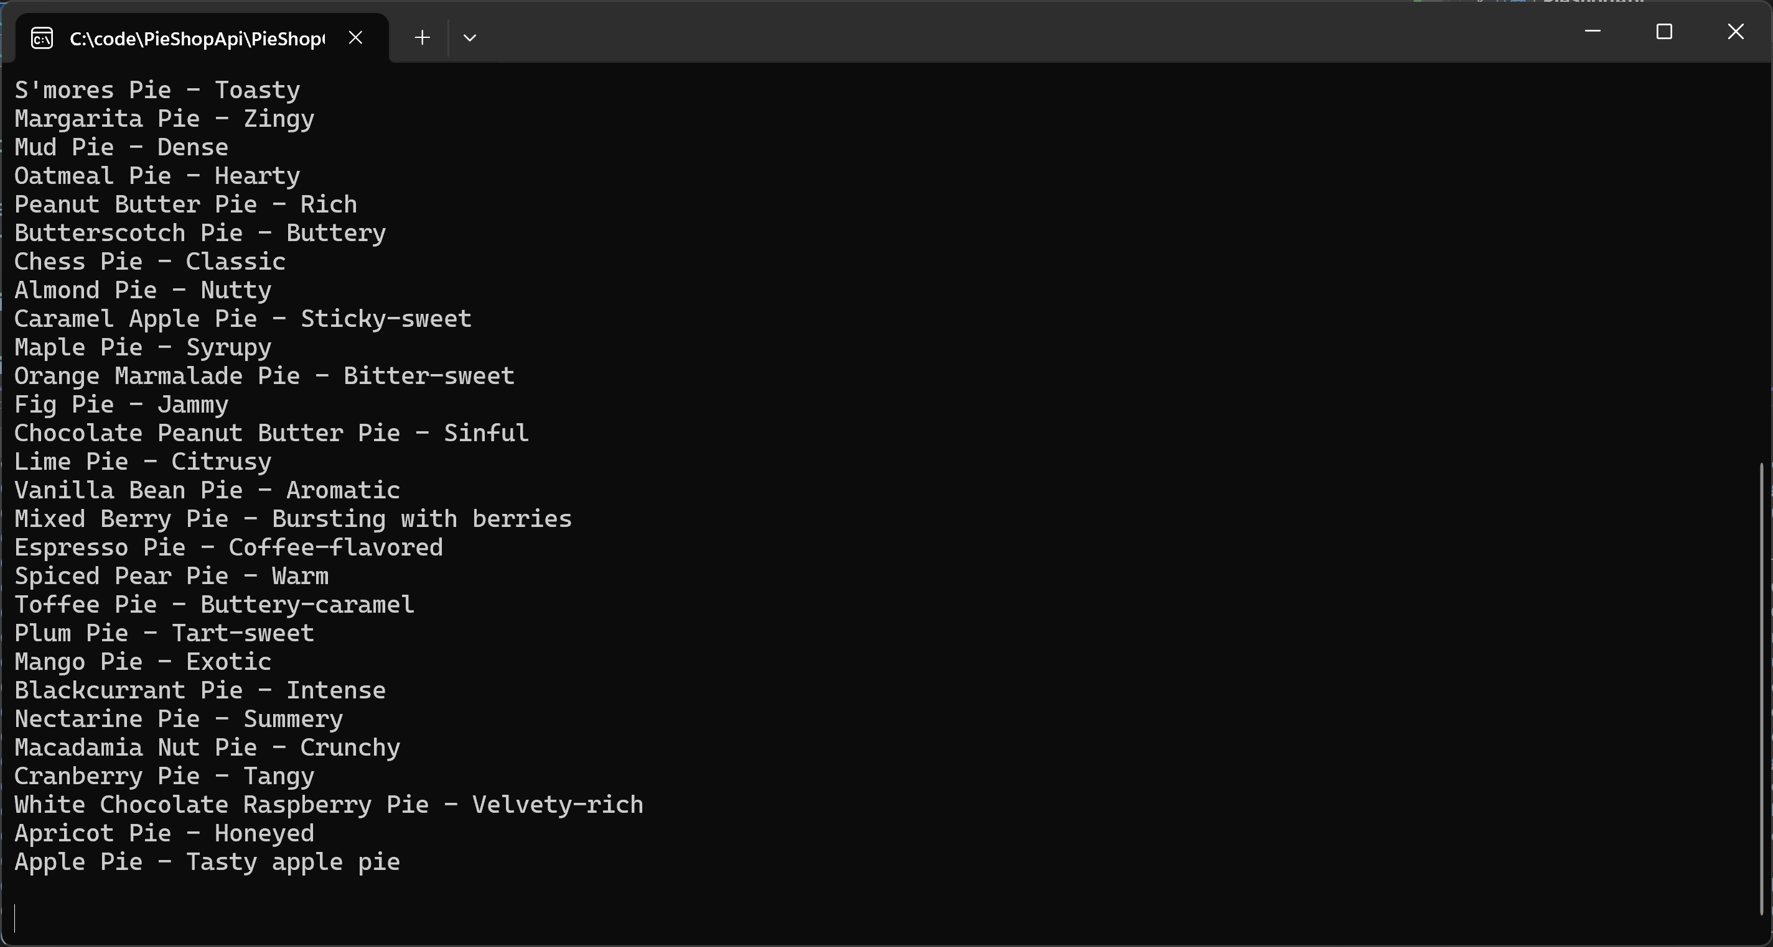

Adding a new Pie
Posting a new Pie works in roughly the same way, but instead of deserializing from JSON to our Pie object, we do it the other way around; we serialize the Pie object to JSON.
Steps:
- Add the following code to the end of the program.cs file
Console.WriteLine("Press any key to add a new pie");
Console.ReadKey();

var newPie = new Pie { Name = "New Apple Pie", Description = "Improved apple pie" };
var newPieJson = JsonSerializer.Serialize(newPie);
var content = new StringContent(newPieJson, Encoding.UTF8, "application/json");

response = await client.PostAsync("pies", content);
response.EnsureSuccessStatusCode();

Console.WriteLine(await response.Content.ReadAsStringAsync());
Console.ReadKey();
- Launch the console application again and verify that the the created Pie is returned from our POST request
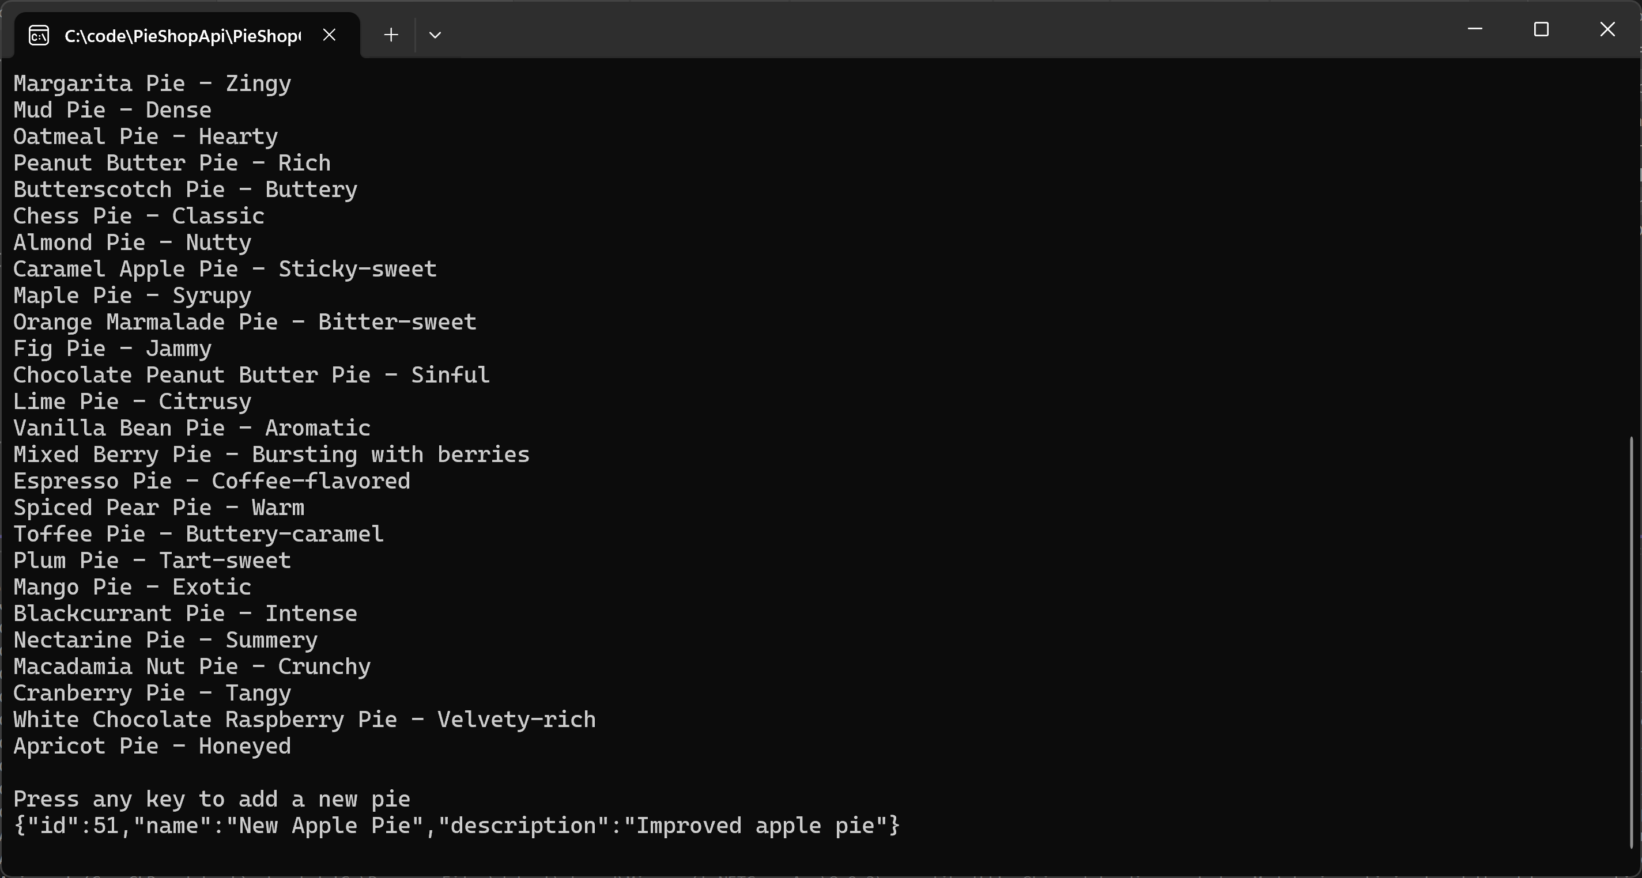
- If we close and restart the console application again (without stopping the API), we should see our new pie being listed in the GET part
